

**CO600**

**Ethics Generator**

Technical Report

Kieran D’Arcy, James Scarry, Taylor McNicol, Ibraheem Jhanji

Supervised by R.O. Kafali

**Abstract**

This is a comprehensive report for the CO600 project ‘Ethics Generator’; the report will feature an overview of the entire development process of the project (named Autonomous Ethics by the four developers), as well as discussing the technical and non-technical features that went into its creation. Throughout this report, there will be an outline of our targets/goals that we aimed to achieve with the development of this program.

The report will also feature our reflection of each step of the development and design. Autonomous Ethics was designed and developed by Kieran D’Arcy, James Scarry, Taylor McNicol, and Ibraheem Jhanji.

Contents

**1 Introduction** 4

**2 Background** 5

2.1 Similar Platforms 5

2.2 Planning Development 5

**3 Requirements** 6

3.1 Minimum Project Requirements 6

3.2 Optional/Non-Critical Features 6

3.3 Possible Extra Features 6

3.4 Non-Technical Requirements 6

**4 Development Planning** 7

4.1 Languages 7

4.2 Web Development 7

4.3 Basecamp 7

**5 Design** 8

5.3 Concept Designs 8

5.1 Graphics Design 8

5.2 Web Design 8

**6 Implementation** 9

**7 Evaluation** 10

7.1 Does Autonomous Ethics Meet the Criteria? 10

7.1.1 10

# **1 Introduction**

Autonomous vehicles and the industry they’re part of have been facing the issue of moral dilemmas/clashes for many years now. While the technology for these vehicles continue to improve and develop, there is one thing that has kept industry experts at a standstill – that is the issue of deciding what a vehicle should do in the event of an unavoidable accident.

Many have expressed discomfort behind the idea of vehicles making these ethical decisions; morals and ethics are hard to centralize based on location, and it is unlikely that the perfect medium for it is even possible to achieve.

Autonomous Ethics aims to test the morals and ethics in a user’s decision-making. It offers the simulation to the user of being a passenger in a fully automated car; the car is approaching a crossing and cannot avoid an accident. Autonomous Ethics randomly generates various scenarios to present to the user, offering them a selection of three options. The program will measure their responses and collect information such as which age group they favor most, and which character(s) they choose to sacrifice more often.

Autonomous Ethics was built with the intention of being a research tool, offering 28 unique characters for use in generated scenarios.

# **2 Background (Taylor)**

## **2.1 The Problem We’re Addressing**

As explained in section one, our project was designed for the purpose of being a tool to conduct research in the area of vehicular autonomy and the moral complications that come as a part of that. Autonomous Ethics seeks to offer concise and realistic data in its results.

## **2.2 Deciding the Setting**

During our planning stage, one of the key concepts we discussed was how the program was going to work at its core – mainly based off of the setting and the functionality of our potential choices. We were narrowed down to a few different areas of autonomy.

We discussed the possibility of autonomous trains, planes, boats, buses, and cars. Although we discussed the idea of developing the program to cater to more than one area, it was a unanimous decision to ensure quality over quantity. We decided to start off on just cars, however later into the project we began discussing how it could potentially be extended to explore different areas.

## **2.3 Creating Uniqueness**

One thing that was important to us while we planned the development of Autonomous Ethics was ensuring its originality and uniqueness as a research tool. We discussed implementing this in a few ways; most notably, the timer feature was one of the first things put forward to make Autonomous Ethics stand out. While the users are taken through their scenarios, they will alternate back and forth between timed interactions and limitless ones. This feature is intended to add a sense of realism to what the program is demonstrating – in a real-life situation, an autonomous vehicle would not have an unlimited amount of time to decide the course of action to take.

Using the timer feature, we can measure differences in user decisions compared to when they had time to think about it and when they did not.

Another feature discussed was the concept of having scenarios given to the user in both first person and third-person perspective.

# **3 Requirements**

## **3.1 Minimum Project Requirements**

## **3.2 Optional/Non-Critical Features**

## **3.3 Possible Extra Features**

## **3.4 Non-Technical Requirements**

# **4 Development Planning**

## **4.1 Languages**

* HTML (Outline the style and content of each page)
* Javascript (Allows the implementation of the randomly generated scenarios)
* CSS (Used to style the page and link jQuery elements to the page)
* Js.node (Has database from where we can access data using jQuery)

## **4.2 Web Development**

## **4.3 Basecamp**

* For general note taking
* Used for meeting alerts and schedule deadlines (internal and external)
* Alerts other members of what has been completed
* To do lists enable team to know what aspects are assigned to them
* The message board is also crucial to get messages across to other members

# **5 Design (Taylor)**

## **5.3 Concept Designs**

At the beginning of our project, we first had to collaborate and create a rough sketch-up of what we thought the final product should look like.

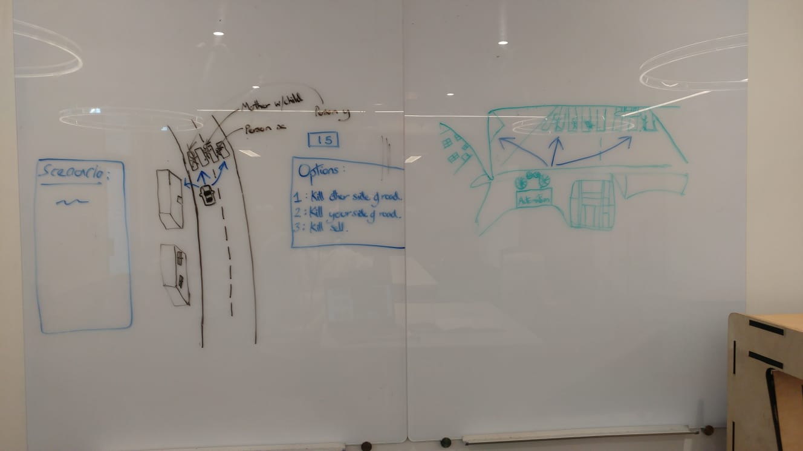

The above image is our group’s collaborative sketch-up. Everyone was instructed to bring their concept drawing; the above is the finished result of all our ideas pooled together. The imagery seen on the right is supposed to portray our program from a first-person view. It was through our collaborative concept work that we were able to decide which key features we wanted to bring forward, as well as what features could help us stand out.

## **5.1 Graphics Design**

Once development for Autonomous Ethics had begun, there soon came a long list of required graphics that were needed to help piece the functionality and intended purpose together. 28 unique characters were used in Autonomous Ethics, all of them from varying age-groups, ability, and class.

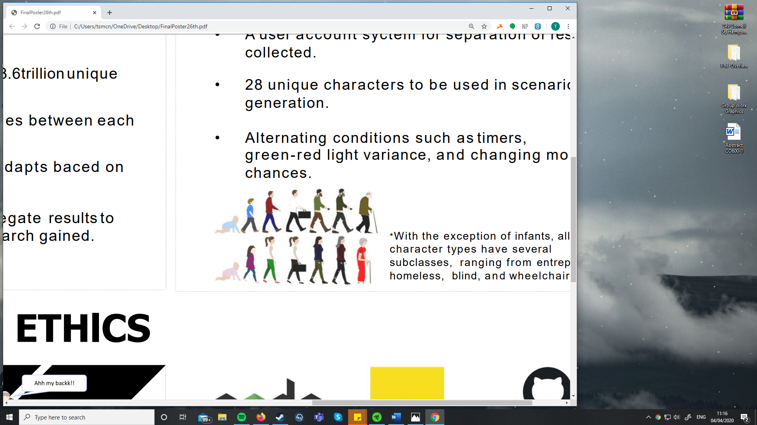

The image seen above is a collection of seven characters from each gender; each individual character seen has a unique difference to the others (age, class, profession, etc.) All graphics are not displayed here, however different variations of the unique characters exist, such as being wheelchair bound and/or having the ‘homeless’ modifier.

Alongside the characters that were individually designed, there were separate graphics for the vehicle, the red and green lights, etc. The environment in which our project takes place was built using Blender.

## **5.2 Web Design**

Talk about web design’s style, functions, etc.

# **6 Implementation**

(Kieran or James may be better off listing the subsections for this part)

## **HTML Structure**

## **Scenario Generator**

## **Image Creation**

## **Mapping Image’s to Scenarios**

## **Index and Database (Kieran)**

## **User ID’s and Result Production**

## **Logic???**

## **Ethical Conclusion (IB)**

# **7 Evaluation**

## **7.1 Does Autonomous Ethics Meet the Criteria?**

### **7.1.1**